|  |
| --- |
|  |
| ERP APPLICATION –QUICK CARDS  **HOW-TO DOCUMENTS FOR THE HCM MODULE** |
| |  |  |  | | --- | --- | --- | | DEPARTMENT OF INFORMATION COMMUNICATION AND TECHNOLOGY | 9/10/18 | AFRICAN REINSURANCE CORP. | |

# **TABLE OF CONTENTS**

TABLE OF CONTENTS 1

INTRODUCTION 2

TECHNICAL ISSUES 3

A. User Not Receiving Emails from the application. 3

B. How to Set Up a Skype Meeting on Microsoft Outlook Desktop Application 4

C. How to create a Request set 6

D. Steps to update grade point value 16

E. How to Create a Responsibility 19

F. Pushing Inward/Outward RMS Transactions into the ERP application. 21

G. Moving Transaction from user1 to user2 23

H. Bar Code Settings 25

FINANCE 30

A. How to run AP list 30

B. Expired Transactions 33

# **INTRODUCTION**

This a quick reference manual to show users how to carry out specific tasks on the ERP application. You will require a valid login to the ERP application and must have a responsibility for the specific module to complete the tasks.

This manual is based on the Technical Issues module of the application is to be discussed. For easy reference, use the Table of Contents to navigate.

If you require any help, please contact as a first line of support, your respective ICT officers. If the issue is still unresolved, log on to the Sysaid application where you can log a request. The ICT department at the Headquarters office will respond.

If this is urgent or you have not received a reply within 2 hours, please contact Toyin Arowolo of the ICTD department at [Arowolo.oluwatoyin@africa-re.com](mailto:Arowolo.oluwatoyin@africa-re.com) or Toe, Lazard on [lazard.toe@africa-re.com](mailto:lazard.toe@africa-re.com).

# **TECHNICAL ISSUES**

## **User Not Receiving Emails from the application.**

**Navigation**: Home

Once logged in, at the top right corner of the screen, **select** ‘**Preferences’**.

**Scroll** to the bottom of the screen for the field ‘**Email** **Style’**.

If the Email style option is ‘**Disabled’**, change to ‘**HTML** **mail’** as shown below. This setting ensures the delivery of Emails.

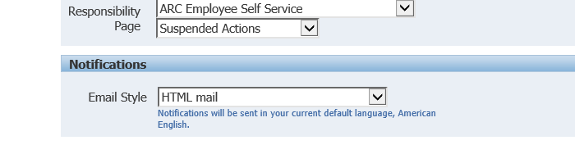

**Click** on the **Apply** button.

## **How to Set Up a Skype Meeting on Microsoft Outlook Desktop Application**

**Navigation**: Microsoft Outlook Desktop Application

**Open** the **Microsoft Outlook application** and **click** the **calendar icon** at the bottom left of the screen, please **see red arrow below**.

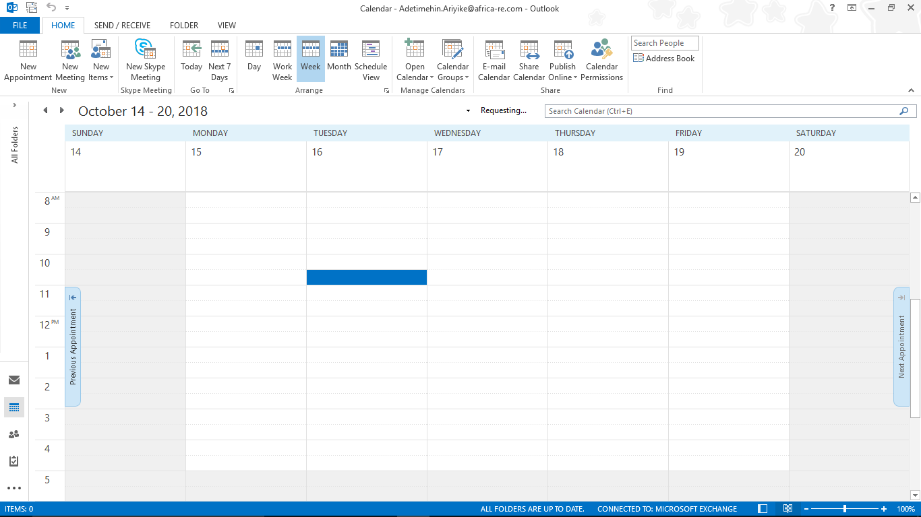

A new screen will appear

**Select** a **calendar slot** to add meeting (see blue rectangle in the image below)

Then **click ‘new Skype meeting’** in the options listed above (also see image below)

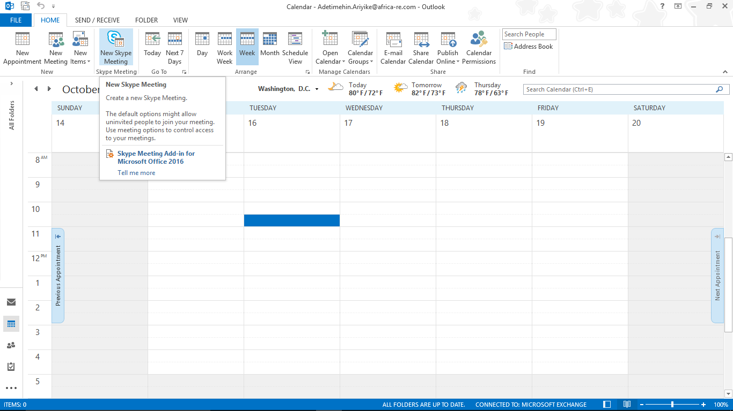

Once clicked, a screen will pop up

**Input** **meeting details** here including meeting participants, duration of meeting, location (set by default to Skype) and any additional messages you may wish to add

The ‘**Join Skype Meeting’** messageinblueisthelinkfortheSkypemeeting and can be clicked once meeting commences to join.

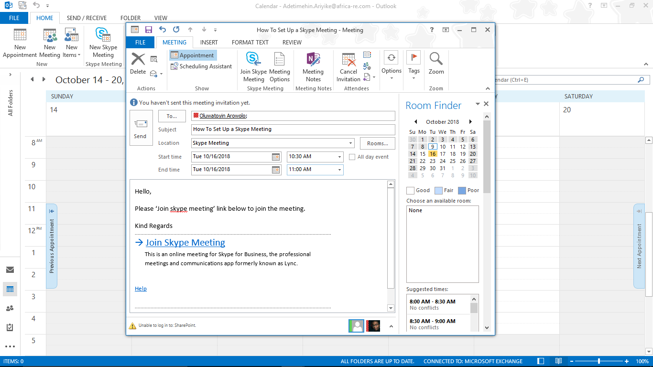

## **How to create a Request set**

Request set is used mostly for the dependent program which needs to run in the sequence order.

Two methods to create the request set

1. Manual method
2. Wizard method

**Manual method:**

**Navigation:** system administrator

**Open** the system administrator and **click** on concurrent, then **click** on set.

Once clicked a screen will pop up.

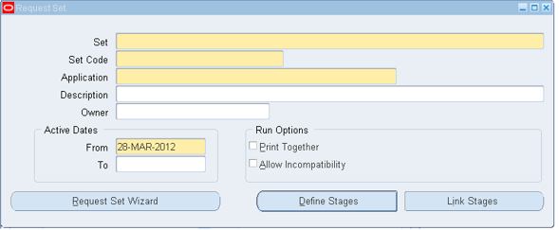

**Enter** the values (for example)

**Set** –XXSATISH weekly report

**Set** **code** – XXSATISH WEEKLY REPORT

**Application** – Application Object Library

**Description** – XXSATISH Weekly Reports

**Owner** – SATISH (you can select from the list of values)

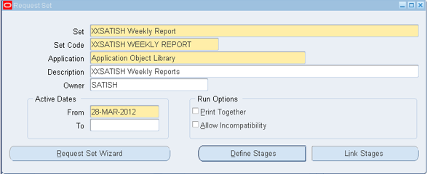

Then now, you **click** on DefineStages

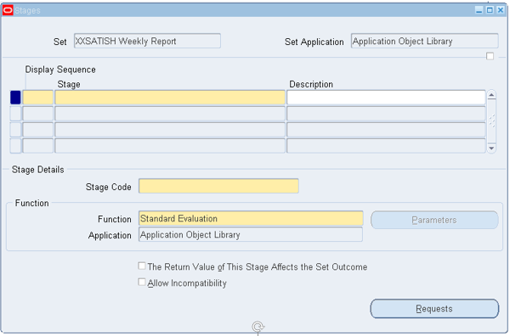

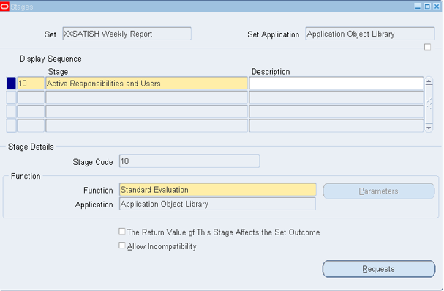

Also, give the display sequence and stage (concurrent program name), then the stage code as 10.

Then **click** on the request button.

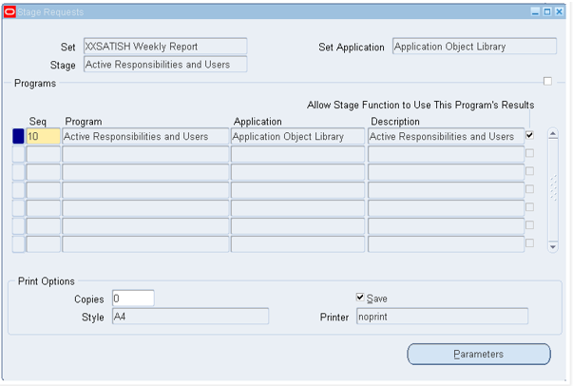

**Give** the sequence value and program as concurrent program name. In the same way repeat the steps, depending on your requirement.

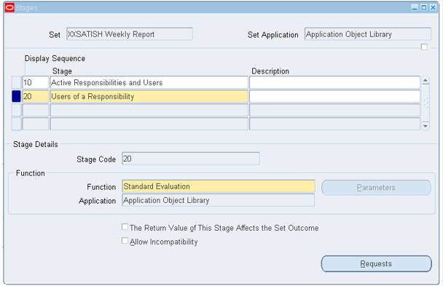

Then again **click** on the **request** button.

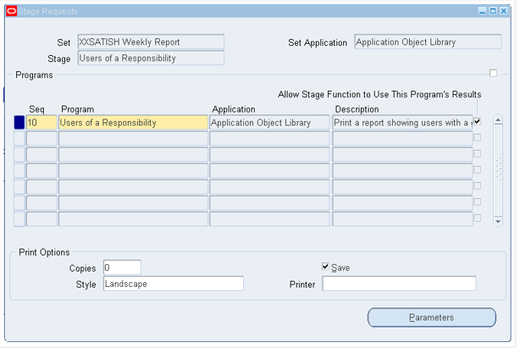

Once your concurrent request are done in the define stage, then **go** **back** to the main request.

Set **form** and then **click** on link stages

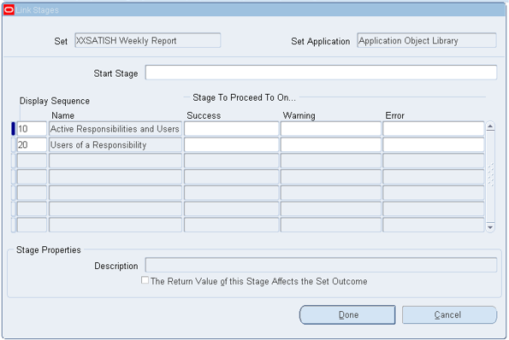

**Specify** the next concurrent program name in the success, warning or error places of the first concurrent program

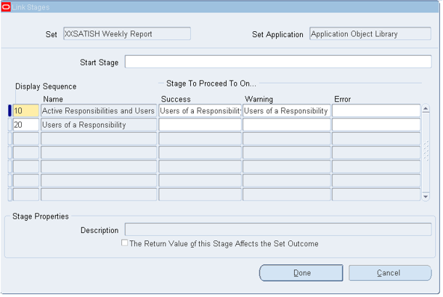

Then **click** on the **done** button, and **attach** this request set to the request group as per your requirement and then **switch** the **responsibility** to that responsibility and **submit** the request.

**Wizard** **Method**:

**Navigation:** system administrator

**Open** the system administrator and **click** on concurrent, then **click** on set.

Once clicked a screen will pop up.

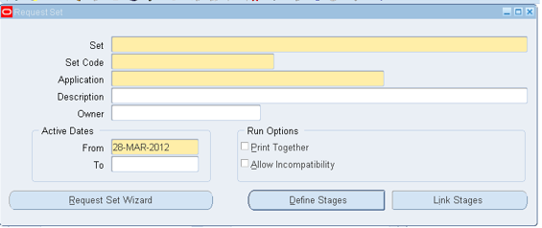

Then **click** on **request** **set** **wizard** button

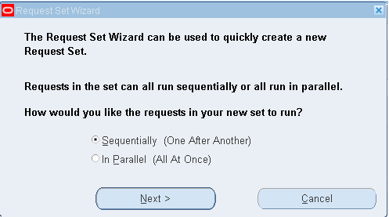

**Select** the **sequentially** or **parallel** button depending on your requirement, then click on the next button

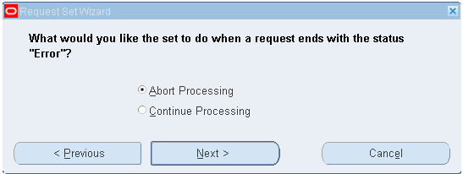

Whenever the request sets (any concurrent program in the request set) goes error then, the process should be aborted.

We can continue the process, if we select the parallel request set, because the concurrent program are not dependable on one another. In sequential concurrent programs may be dependent.

**Click** the **next** button

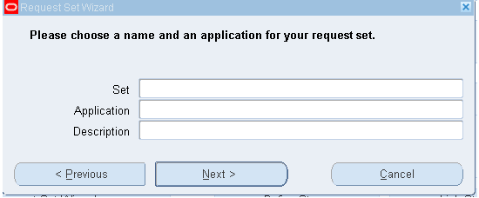

**Enter** the values for

**Set** – XXSATISH Weekly Report1

**Application** – Application Object Library

**Description** – XXSATISH Weekly Report1

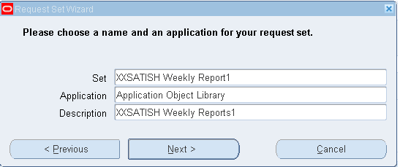

And **click** on the **next** button

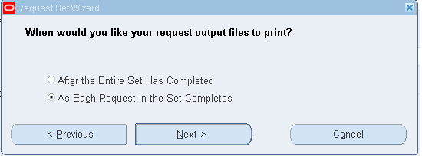

Most times what we use is “**As each request in the set completes**” because, if any concurrent programs is completed, we can **click** on view out and we can view the output of that concurrent program and also, if the request set is not completed too.

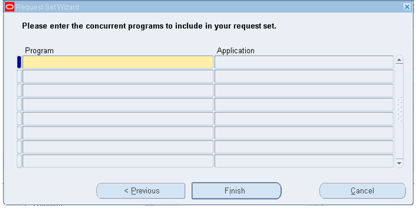

Please **enter** all concurrent program which you want to attach to the request set.

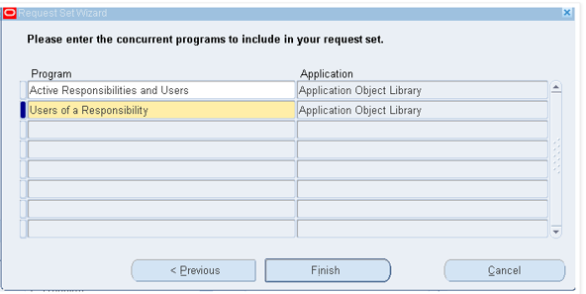

Then **click** on the **finish** button

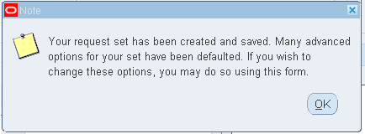

It will display the message **that your request set, has been created and saved**.

Then **click** the **OK** button.

Then **query** for your request set and **check** it.

In wizard method set code is generated by itself.

## **Steps to update grade point value**

1. **Log in** with an **Accounts HR Manager** Responsibility.
2. **Navigate to** >>ARC HR Manger >>Grade Setup

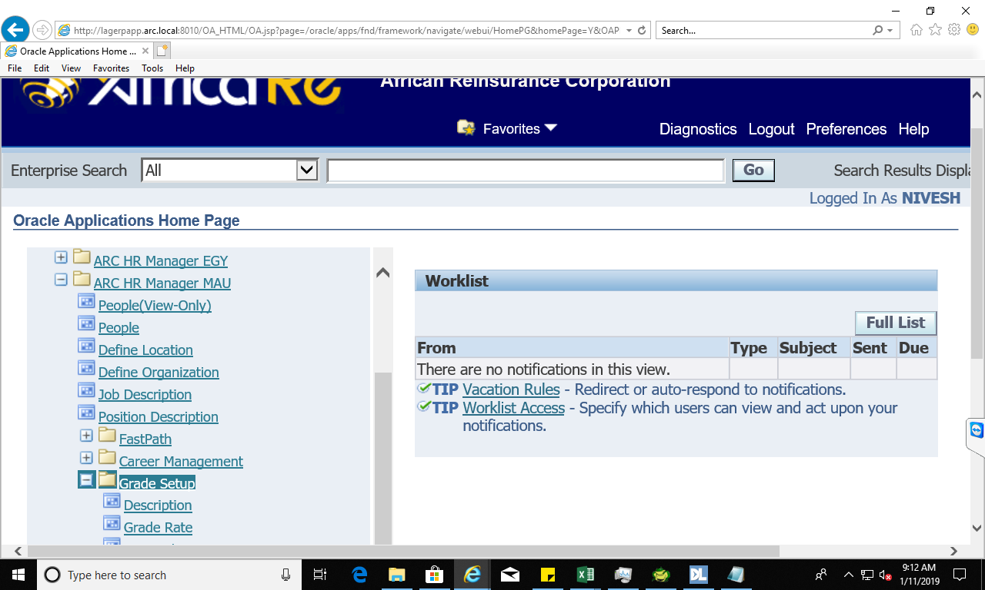

1. Under **Grade Setup** Menu, **Click** on **point values**

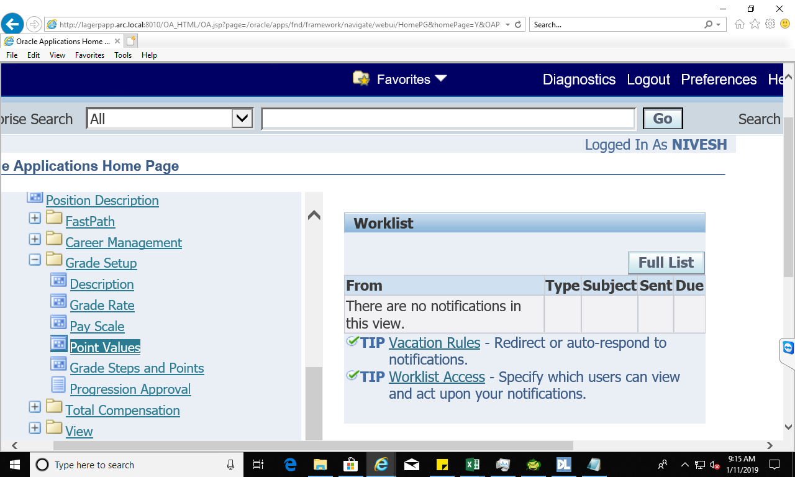

1. Once the form is opened, Please **change** the **effective date** to 01-JAN-2019

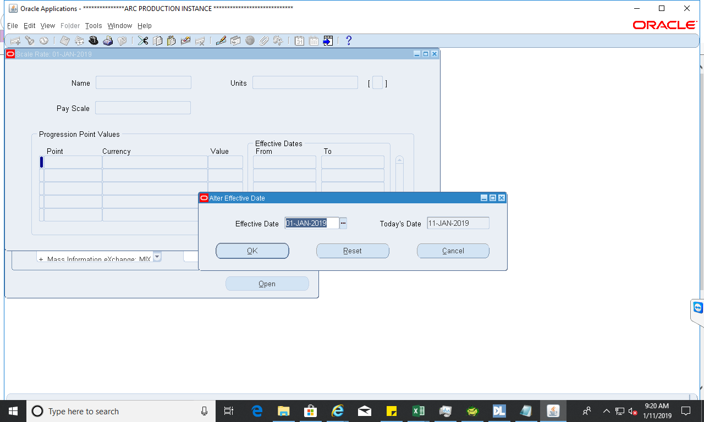

1. **Enter** in query mode **( F11)** and search the point scale values for your county.

For example Egypt we will have

* Basic Salary_Egypt
* Staff Rent Subsidy_Egypt
* Transport Allowance_Egypt

**Please note we will have three scales for each county to update in the application**

* Basic Salary
* Transport
* Staff Rent Subsidy

1. **Click on** the **point values** and **update** it to new amount

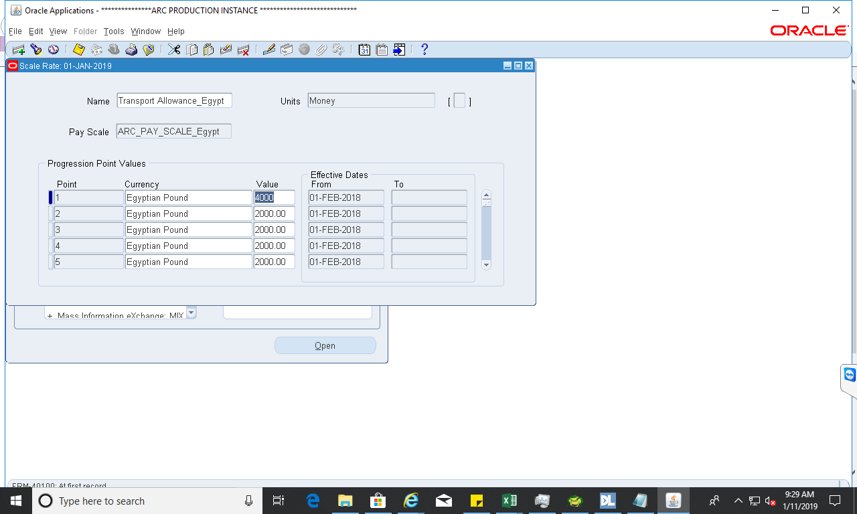

1. **Save** the changes with option update

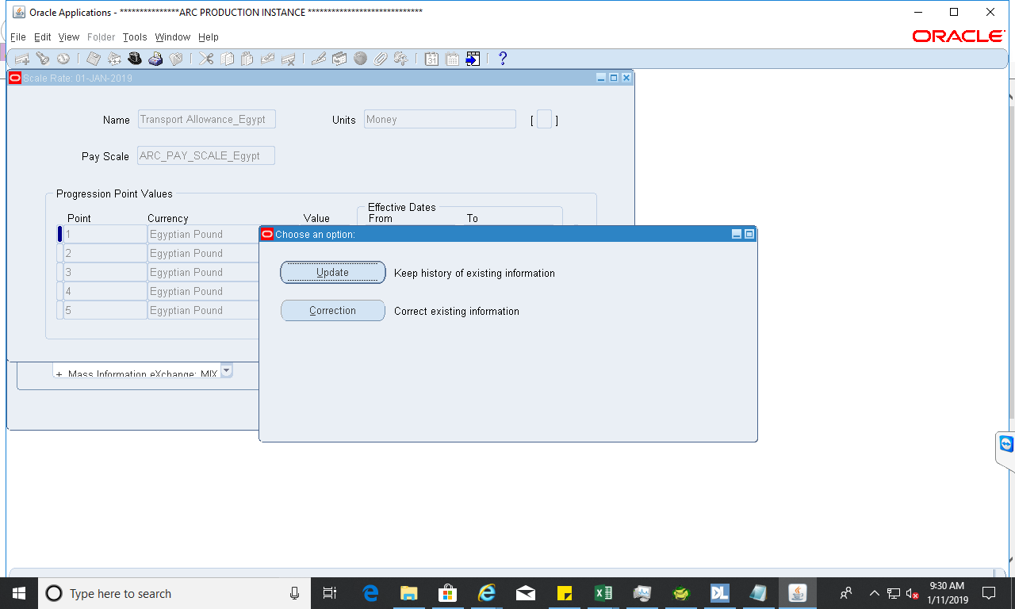

1. Repeat step 5 to 7 for all the points

## **How to Create a Responsibility**

1. Switch to System Administrator responsibility and **navigate** to below path

**Navigation**: System Administrator → Security → Responsibility → Define

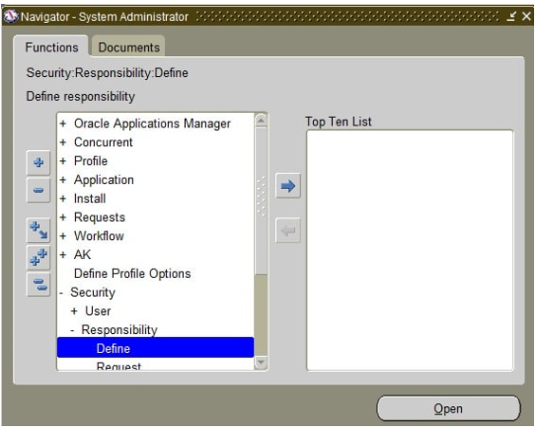

1. The below screen will appear. **Fill** in the required information

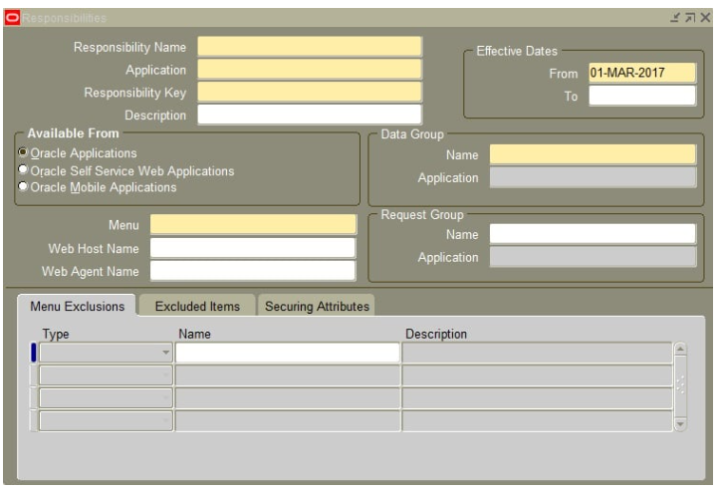

1. Once you **fill** the above details, responsibility form will look as below

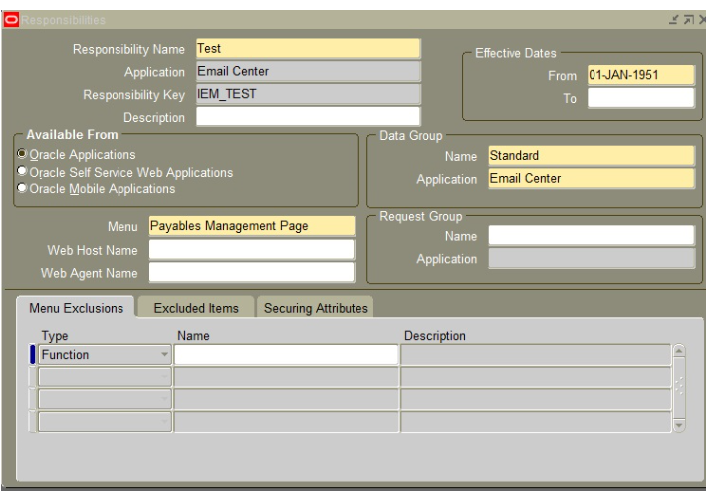

## **F. Pushing Inward/Outward RMS Transactions into the ERP application.**

**Navigation: Log** into oracle forms with the appropriate responsibility.

Choose **single request** (to run a single concurrent program) or **request set** (to run a set of concurrent programs), then select ok.

The **submit a new request form** opens

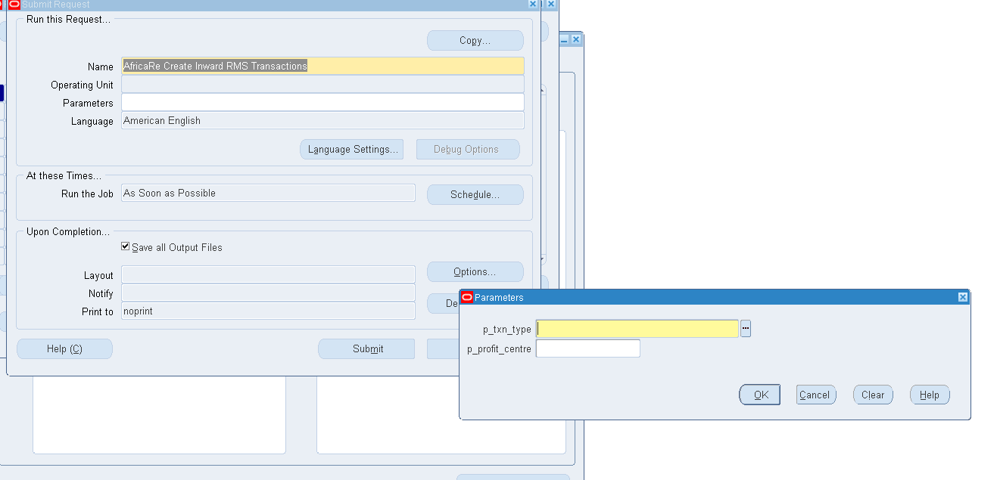

**Enter** the following values:

**P_profit_centre**: <<Profit Centre>> E.g. WES

For Inward transactions

**Name**: AfricaRe Create Inward RMS Transaction

For Outward transactions

**Name**: AfricaRe Create Outward RMS Transaction

Once the program name is selected, a dialog box pops us.

**Enter** the following values in the fields shown:

**p_txn_type**: INWARD (Inward transactions) or INWARD_R (Reversed inward transactions)

**p_txn_type**: OUTWARD (Outward transactions) / OUTWARD_R (Reversed outward transactions)

**Click** the **OK** button.

**Click** the **Submit** button.

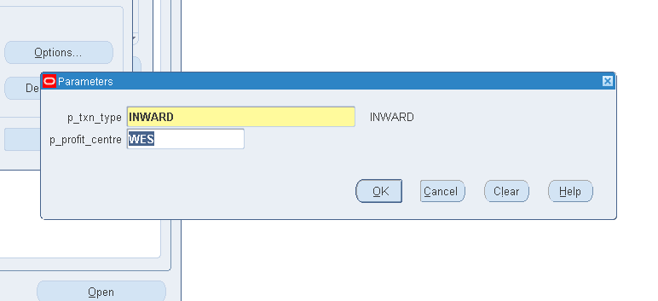

Once the program run is complete, **confirm** the transactions are on the ERP by:

1. Ensure the program run is successful. The status is completed and the phase is normal.
2. **************

## **Moving Transaction from user1 to user2**

1. The user must be a **sys** **admin**.
2. Switch to System Administrator responsibility and **navigate** to below path

**Navigation**: System Administrator → administrator workflow→ workflow → notification

**Fill** in the information required

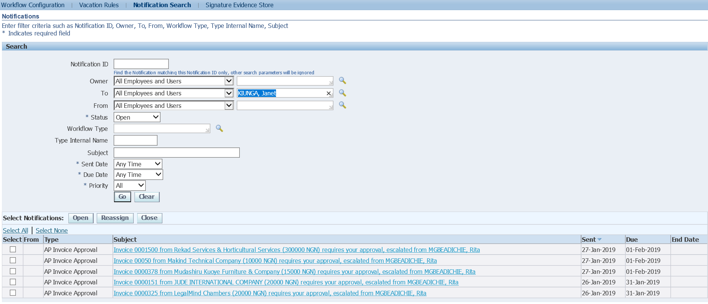

**Click** ok

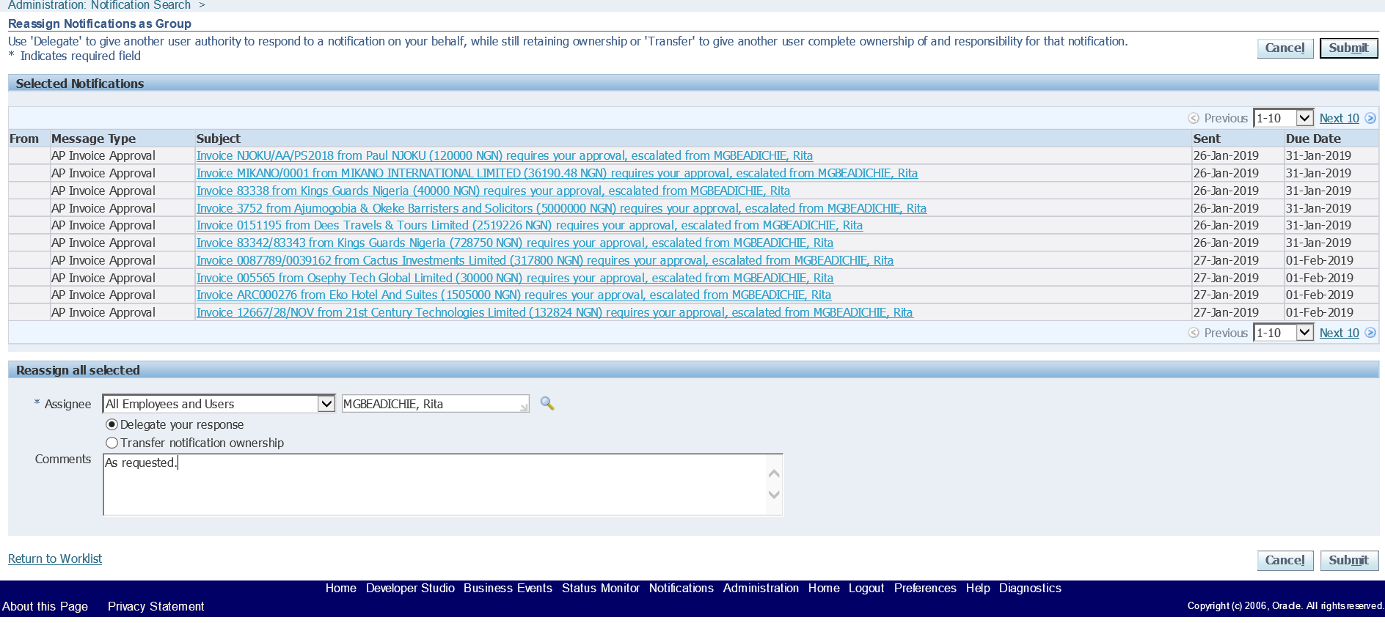

**Click** on submit

## Bar Code Settings

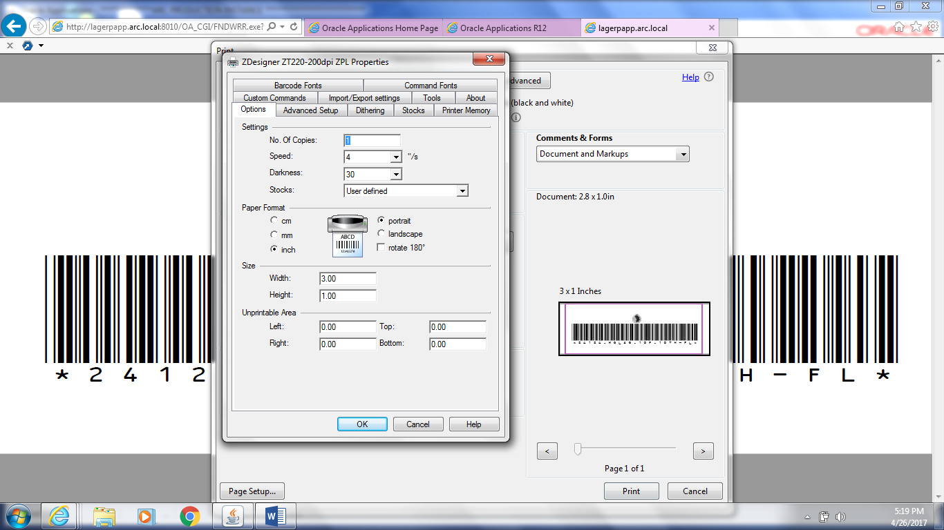

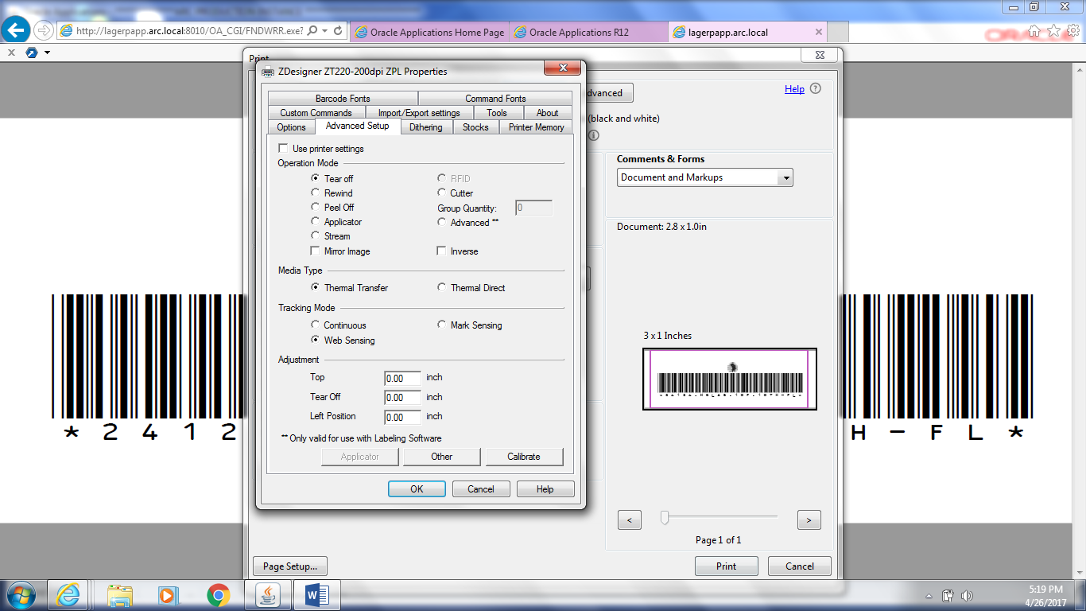

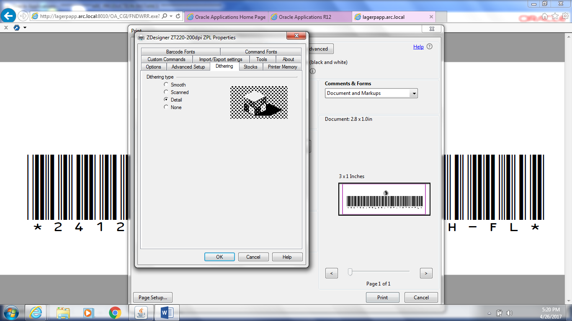

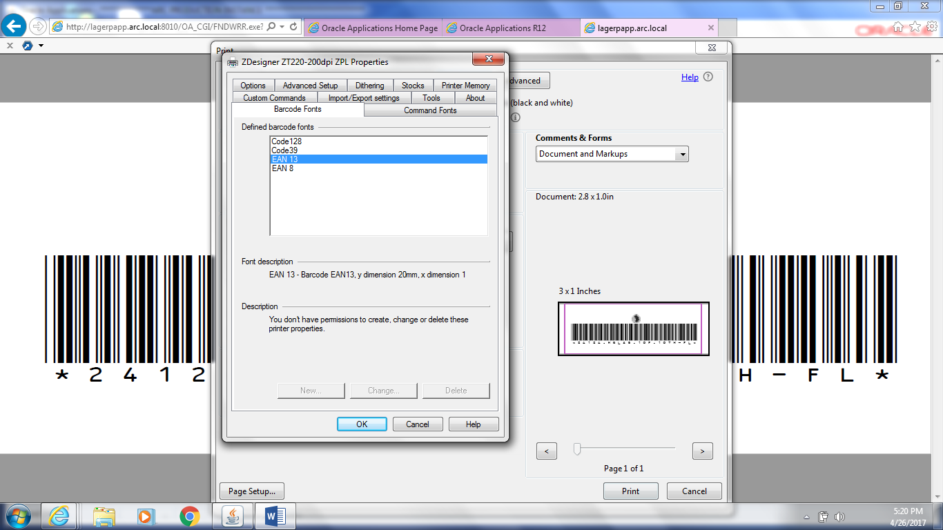

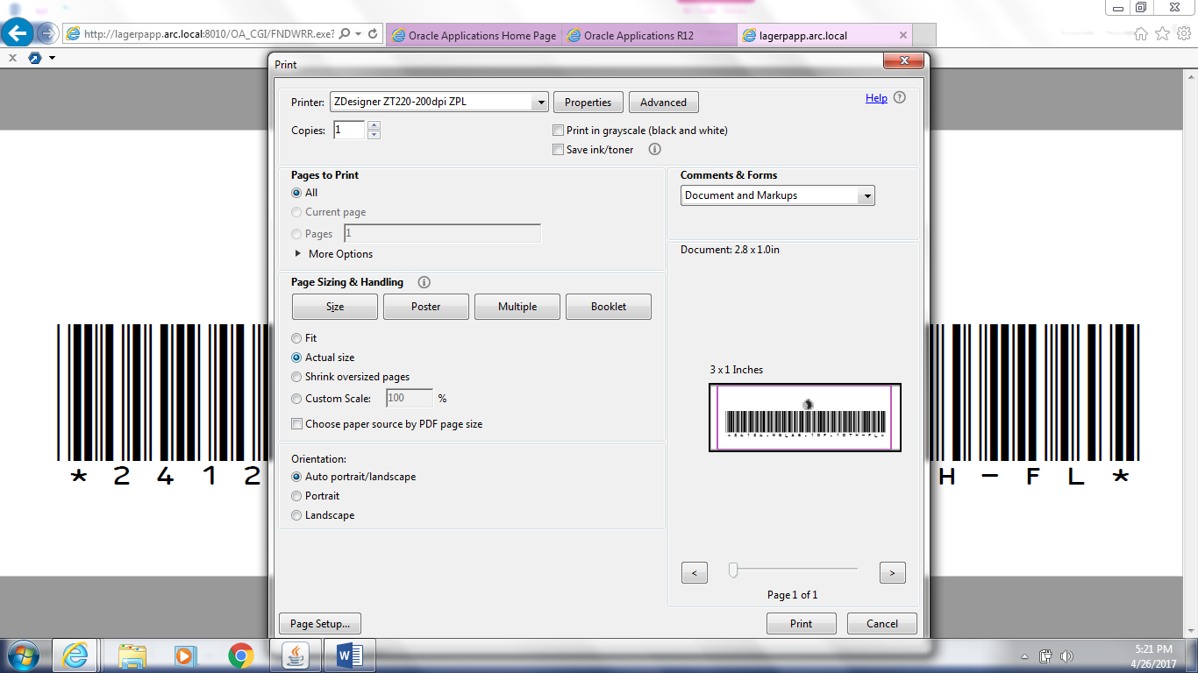

# **FINANCE**

## **How to run AP list**

1. **Go** **to** invoice workbench, **query** the invoice for which you want to run **AP** **list** 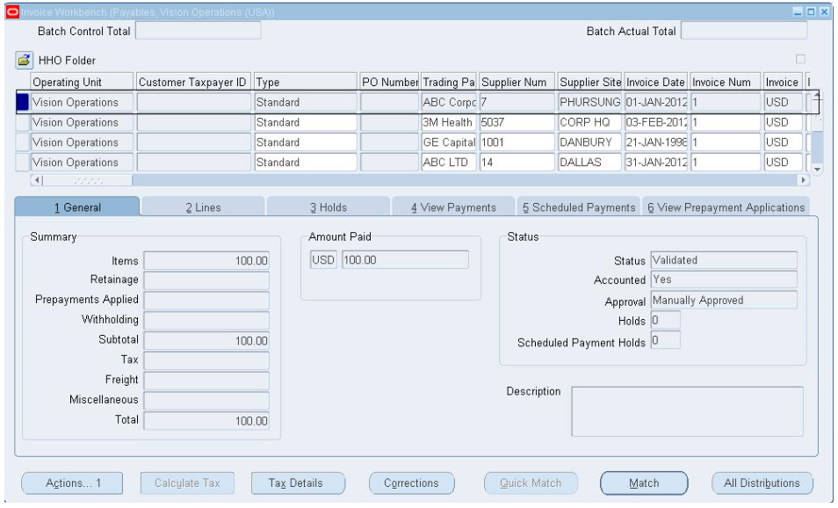
2. **Go** **to** application diagnostics responsibility and **click** on Diagnose. Below page appears

**Select** the application by clicking “**Select** **Application**”

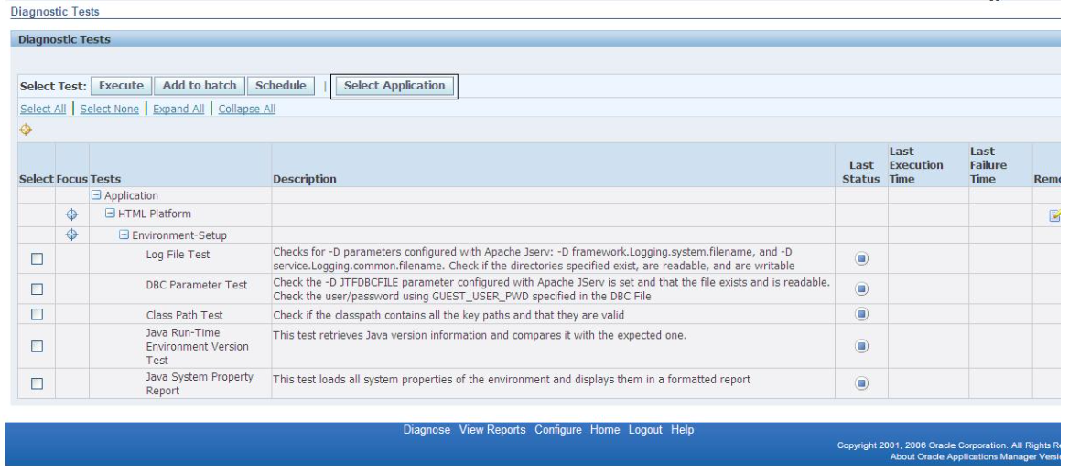

1. **Select** the application by selecting short name as “**SQLAP**” and **click** on select.

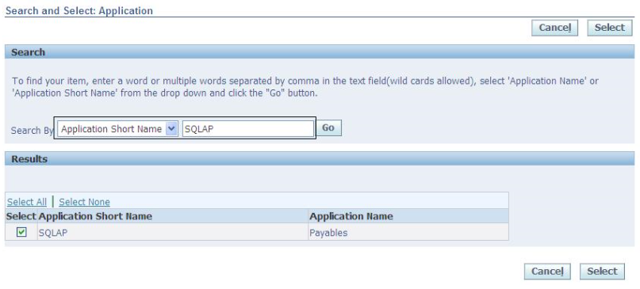

1. **Go** **to** invoice and **select** check box invoice data. **Click** on execute button.

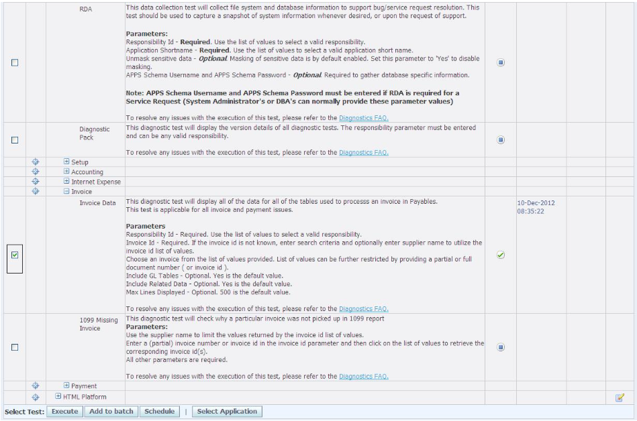

1. Upon clicking execute button, the below page appears. **Enter** all the parameters in the respective columns.

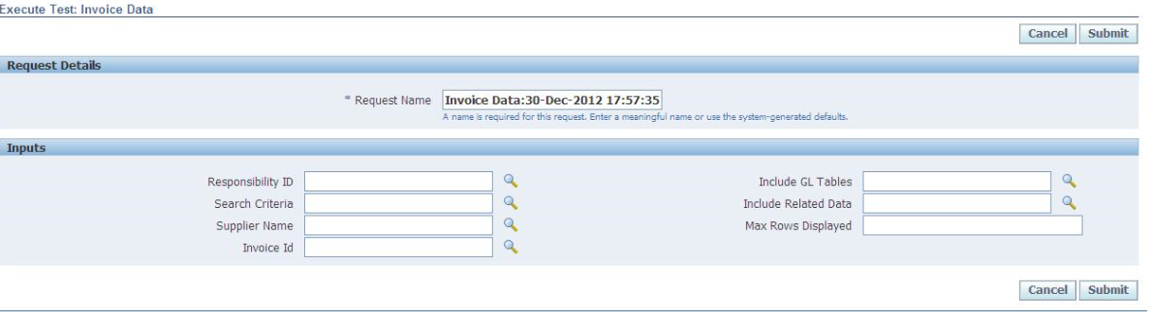

1. **Select** the responsibility, **Invoice** **ID** or **Check** **ID** and the **Supplier** **Name** from **LOV**.

**Select** search criteria as “**Invoice** **or** **Check**” and include GL tables and Include Related Data as **YES**.

**Max** **Rows** Displayed as **500**. Also, **find** the parameters filled screen for your reference. Upon filling the parameters, **click** on submit

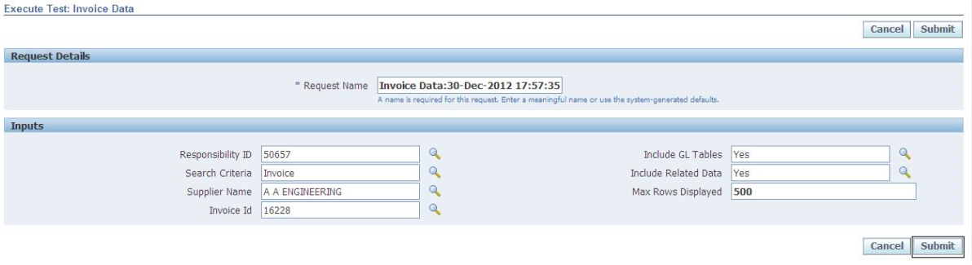

1. After submitting the below page appears.

**Click** on refresh button till the time download report column enable with check-box

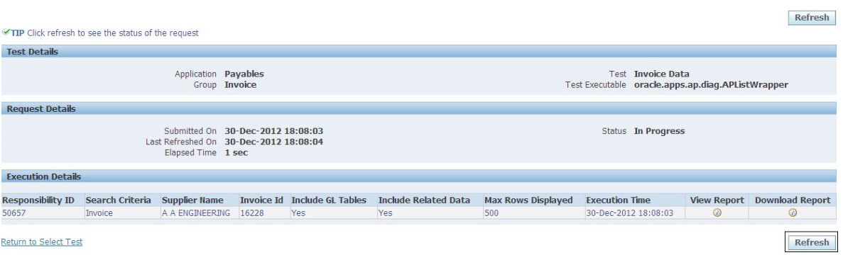

1. Once report is ready to download. The check-box gets enabled in download report column. **Find** the enabled screen for your reference

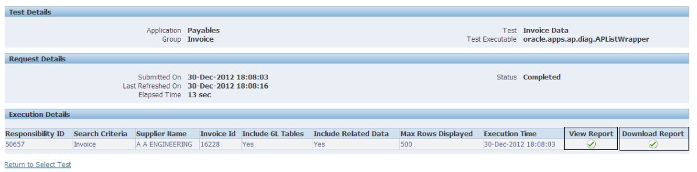

1. Report is ready for view as well as for downloading. For downloading **click** on check-box on download report. To view **click** on check-box on view report.

## **Expired Transactions**

**Backup** the gl_je_batches

**Create** table gl_je_batch_bak as **select** * **from** gl_je_batches

**Update** gl_je_batches

**Set** approval_status_code = **'R'**

**Where** je_batch_id = **367229**

**And** approval_status_code = **'I'**

**And** status = **'U'**;

**Select** approval_status_code, status **from** gl_je_batches

**Where** je_batch_id=**367229**

**Create** table gl_je_batch_bak_31jan19 as **select** * **from** gl_je_batches